HEART
The Heartland Environmental Alliance for Resilience & Transformation (HEART) - Improving the lives and livelihoods of people across the Heartland through climate resilience research, education, and outreach.
Authors:
Gregory R. Carmichael, University of Iowa
Robert J. Swap, NASA
Eric D. Hunt, University of Nebraska- Lincoln Extension
Jesse Bell, University of Nebraska Medical Center
Jesse D Berman, University of Minnesota
Charles O. Stanier, University of Iowa
Matthew J. McGill, University of Iowa
Cheyenne M. Morgan, University of Oklahoma
Tyson Ochsner, Oklahoma State University
Dennis S. Ojima, Colorado State University
R. Bradley Pierce, University of Wisconsin
Ana P. Barros, University of Illinois
Hank S. Miller, Nebraska Indian Community College
James Rattling Leaf, University of Colorado, Boulder
Joshua K. Roundy, University of Kansas
Aliasger K. Salem, University of Iowa
Jun Wang, University of Iowa
Jerry W. Wegiel, University of Nebraska-Lincoln
Daniel Wildcat, Haskell University
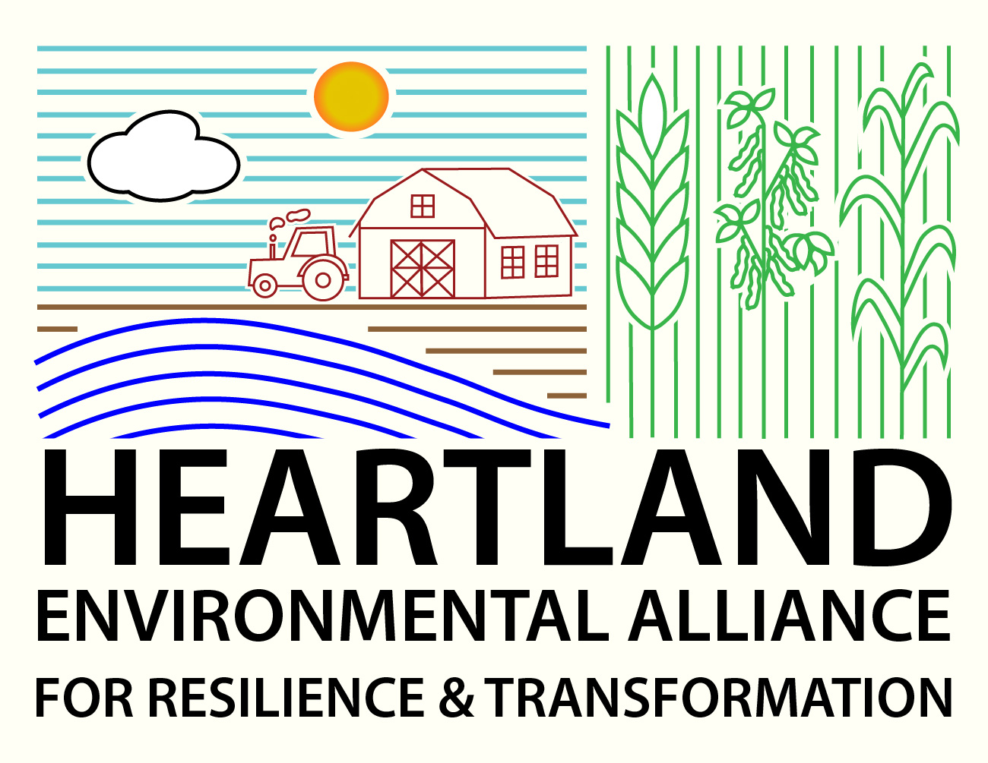
Abstract
HEART is a university-led alliance of institutions, agencies, and industries committed to voicing the needs of the states in the central land area of the US and advancing research to develop innovative environmental solutions that strengthen communities and support policymakers to improve the lives and livelihoods of people across the Heartland. The Heartland is the ‘Breadbasket’ of the Nation and home to the nation’s largest aquifer and largest river basin. However, the Heartland is highly vulnerable to the impacts of our changing environment. HEART aims to leverage and amplify the existing strengths of the members to develop robust, open, transformative solutions for mitigation of and resiliency to environmental changes threatening the region’s water, food, and energy security. We are excited by the possibilities of HEART and welcome further engagement and suggestions.

Plain language Summary
Institutions and stakeholders in the region are establishing the Heartland Environmental Alliance for Resilience and Transformation (HEART) (http://heartaliance.org/) with the goal of developing innovative solutions that help make communities across the Heartland more resilient to environmental changes that threaten the region’s water, food and energy security.
Why HEART?
The region of the United States situated between the Appalachian and Rocky Mountains, commonly referred to as the “Heartland,” plays important roles in the economy and national security. The Heartland is the ‘Breadbasket’ of the Nation, accounting for 60% of U.S. agricultural production [1], and is also home to the nation’s largest aquifer and largest river basin. However, the Heartland is highly vulnerable to the impacts of our changing environment. In recent years, this region has experienced extreme drought, derechos, flooding, wildfire, wildfire smoke and elevated air pollution, extreme heat, significant declines in groundwater, rapid changes in lake levels, and back-to-back years with record low streamflow on the Mississippi, the nation’s most economically important and iconic river.
These natural disasters directly impact the livelihoods of people and communities that are essential economic drivers of the Heartland, the United States, and nations around the world. For example, the historic 2012 drought affected the entire Heartland and had widespread impacts on agriculture with corn yields reduced by four billion bushels and 27% from expected levels [2]. The August 2020 Iowa derecho damaged an estimated two million acres of corn and 0.6 million acres of soybeans during this singular event [3].
Furthermore, these events are increasingly expensive to businesses and governments alike. The US damage due to events each causing at least a billion-dollar damage over 2014 - 2023 are at a historic high, exceeding $1.2 trillion [4]. Kansas, Nebraska, and Iowa alone have each accrued damages due to severe weather events on average of more than $5 billion per year over the last five years (with Iowa’s damages of $15B) [5].
Innovative solutions are needed to make Heartland communities more resilient to environmental changes. Increasing resilience to these natural disasters requires co-development of solutions that bridge local knowledge to new discoveries and emerging technologies for beneficial local applications. Many Heartland communities are intricately connected to the land where they have lived and worked for generations and possess a collected knowledge of how valuable and variable nature can be in the region. In fact, most of the Heartland's population resides in small and medium-sized cities with populations under 50,000, distributed across the landscape. These regional economic centers are convergence nodes for critical infrastructure including energy and communications networks, and therefore essential for regional risk assessment and resilience planning. Because of these coupled human natural systems, the Heartland’s water, food, and energy production are particularly vulnerable to environmental changes.
The Heartland is also home to many of the nation’s top institutions of higher education where engineering, technology, agricultural sciences, human health, and natural resources are primary focus. Furthermore, it is also home to innovative commercial enterprises critical to the Nation’s economy, including major companies such as United Health Group, Cargill, ADM, American Family Insurance, Target Corporation, 3M, Kiewit Corporation, General Mills, John Deere, and Berkshire Hathaway. The region has tremendous expertise, knowledge, and capabilities that enable innovative approaches to education, physical, environmental, and medical science, technology, engineering, and Cooperative Extension.
Through collaboration, there is an opportunity to both realize the efficiencies of shared situational awareness and leverage the full potential of these centers of expertise to increase resilience across the Heartland. Bringing these vast stores of cross-disciplinary knowledge together and making relevant information easily accessible to those who call the Heartland home is our best chance to identify and implement the solutions needed to enhance resilience and sustainability across the region.

The Alliance
With this motivation, institutions and stakeholders in the region are establishing the Heartland Environmental Alliance for Resilience and Transformation. HEART is a university-led alliance of institutions, agencies, and industries committed to collectively voicing the expressed needs of the region and advancing research to develop innovative environmental solutions that strengthen communities and support policymakers to improve the lives and livelihoods of people across the Heartland. This alliance recognizes and builds upon abilities, assets, and expertise across the diverse breadth of sectors. HEART aims to leverage and amplify the existing strengths of the members to develop robust, open, transformative solutions for mitigation of and resilience to environmental changes.

The goals and objectives of HEART are to: a) advance resilience research; b) produce actionable information; c) speak as a collective voice for the Heartland in national resilience decision-making through targeted education, engagement and outreach; d) develop robust platforms for sharing situational awareness across sectors that advance regional resilience; e) upgrade research and observing infrastructure of the region to address challenges related to environmental changes; and f) inform and influence future directions of governmental research and operational agencies that pertain to resilience in the Heartland. Examples of this include but are not limited to NASA's Decadal Survey and other National Earth observation strategies and initiatives (e.g., NASA’s Westcoast & Heartland Hyperspectral Microwave Sensor Intensive Experiment (WH2yMSEI) and the Adaptation and Response in Drylands (ARID) campaign).
The Nebraska Meeting
HEART grew out of a series of meetings under the title of Harnessing the Heartland. The initial meetings took place in the state of Nebraska, co-hosted by the University of Nebraska-Lincoln from February 26 to February 28 and at the University of Nebraska Medical Center from February 29 to March 1, 2024. These meetings drew approximately 150 different participants from multiple societal sectors and were designed to increase situational awareness and technical interchange across academic, private, civil, and governmental sectors. The goal was to realize the current and future intellectual, economic, and decision-making potential of the region to advance resilience research.
General discussions took place around the following topics: Mesonets; land/atmosphere interactions; water and agriculture; models and actionable information; groundwater quality/quantity; and impacts on human health. Additional discussions focused on how the group could have more influence on new research opportunities and be more responsive to research opportunities. Discussions also took place on how a coordinated Heartland activity could help the region impact the next NASA Decadal Survey, leverage the NASA Adaptation & Response In Drylands (ARID) scoping study and the NASA West-coast Heartland Hyperspectral Microwave Sounder Intensive Experiment (WH2yMSIE) campaign as a pathfinder for a future NASA Planetary Boundary Layer Decadal Survey Mission.
The Nebraska meetings generated tremendous energy and enthusiasm to continue the dialogue. There was unanimous support for subsequent activities aimed at formally establishing a consortium of multi-disciplinary, intersectoral institutions, focused on shaping climate resilience science, technology, monitoring, and modeling efforts that span from below the Earth’s surface to space. The intent is to help focus efforts on the region and better align them with the needs and priorities of this region, where environmental changes can have significant cascading impacts on the national economy and global food security.
Due to the strong interest and growing momentum from the initial meetings in Nebraska, a subsequent targeted workshop was held focused on developing a refined concept and structure for a Heartland consortium. A subset of institutional participants (ca. 12-15 from a dozen institutions) met on a biweekly basis in advance of the next meeting.
The Iowa Meeting
The September 2024 Harnessing the Heartland workshop at the University of Iowa focused on working out the structure and function of a multi-institution consortium for land/atmospheric science and resilience. With the theme of lives and livelihoods, a focused group of 40 participants came together September 10-12 to discuss potential consortium designs to reach goals in improved educational pathways for students, workforce development opportunities, and information that positively impacts our stakeholder communities (e.g., agriculture, weather, disaster recovery, public health, industry, energy systems, climate resilience, urban and regional planning). The workshop was structured with daily plenary discussions, followed by small group discussions, and concluded with hybrid debrief sessions in the late afternoons.
The first day of the workshop focused on the articulation of the rationale for the consortium, its overarching aspirations and identifying science objectives. The first panel focused on the region’s grand challenges of health, environmental change and severe weather that require deep and extended collaboration. This was followed by a panel on key thematic areas for consortium focus, which focused on the question: What is one hard question that you want to solve in next 5 years in areas such as public health, water, agriculture, resiliency, actionable information, extreme weather events, livelihoods, and human dimensions? The panels were followed by breakout groups that worked on further developing big picture questions and overarching themes, thematic focus areas, and identifying a first round of collaborative initiatives for the consortium.
The second day was devoted to how a consortium could help in building community and co-creating innovation, applications, and outreach. The first panel explored community perspectives from the views of stakeholders, rights holders, and end users. The second panel explored examples of organizational structures of existing consortia or cooperative organizations, to help identify structures, example missions, and funding models for the heartland consortium. This was followed by a third panel on how engagement, co-creation, teaching, training, and workforce development would factor into the consortium design. These topics were further discussed in a series of breakout groups.
The final day focused on the road forward and institutionalizing broad-based collaboration. The first panel explored funding models for consortiums, including large center grants, membership fees, and philanthropy. The final workshop panel engaged university leadership (vice-presidents from various institutions in the region) in discussing key elements of successful consortia and collaborations and sharing ideas on how a consortium could strengthen the impact of the heartland.
As an outcome of the Iowa workshop, it was decided to formally launch the Heartland Environmental Alliance for Resilience and Transformation, as a collaborative effort to empower the Heartland region of the United States to actively participate in shaping research, education, and extension activities that affect the lives and livelihoods of its residents. This alliance seeks to leverage the region's diverse assets and expertise across academic, public, private, tribal, and commercial sectors to address climate resilience challenges. Focus areas identified include water management, agriculture, environmental change impacts, and human health. The alliance also aims to provide a unified voice for the Heartland in national decision-making processes, particularly in relation to funding opportunities from NASA, NOAA, USDA, NSF, NIH, DOE, and other federal agencies. HEART emphasizes collaboration, shared situational awareness, the leveraging and enhancement of existing regional strengths and capabilities, and the development of actionable information to enhance regional resilience in the face of environmental changes.
The Road Forward
HEART is evolving from a concept into an alliance. This effort draws its strength from active institutional participation where members undertake research, education, and outreach for and about the region, under the larger umbrella HEART, and from the perspective of a coupled human and natural system which is viewed holistically as part of the integrated Earth system. An executive committee is serving as the coordinating body, drafting the terms of reference and governance for HEART, and working on a sustainable funding strategy. This alliance represents a significant effort to unify and empower the Heartland region in addressing critical environmental and societal challenges.
The road forward to success will depend on continued engagement, clear communication, and the ability to deliver tangible outcomes that benefit the region and contribute to national objectives in climate resilience and environmental management. Next steps will include: developing a strategic plan with clear milestones and deliverables; achieving early successes; engaging through various channels (EOS, BAMS, local press, social media, national conferences such as AGU and AMS); pursuing collaborative research proposals (EPSCOR, NASA, NOAA, NSF, etc.); innovating in education and training among the members and across the alliance; and launching new platforms, for example, a Heartland Resilience Think Tank to incubate innovation and receive feedback on community needs.
We are excited by the possibilities of HEART and welcome further engagement and suggestions. The next planned meeting of HEART is scheduled for fall 2025 hosted by the University of Wisconsin – Madison. This third meeting will provide an opportunity for updates on HEART strategic planning and governance, discussing progress on collaborative research proposals, and highlighting recent successes, including coordinated participation in NASA WH2yMSIE campaign. The Madison meeting will also be an opportunity to further engage federal, state and local communities with strong commitments to advance resilience research within the Heartland.
Further details of the past and future planned activities of the alliance can be found at the HEART website (http://heartaliance.org/).

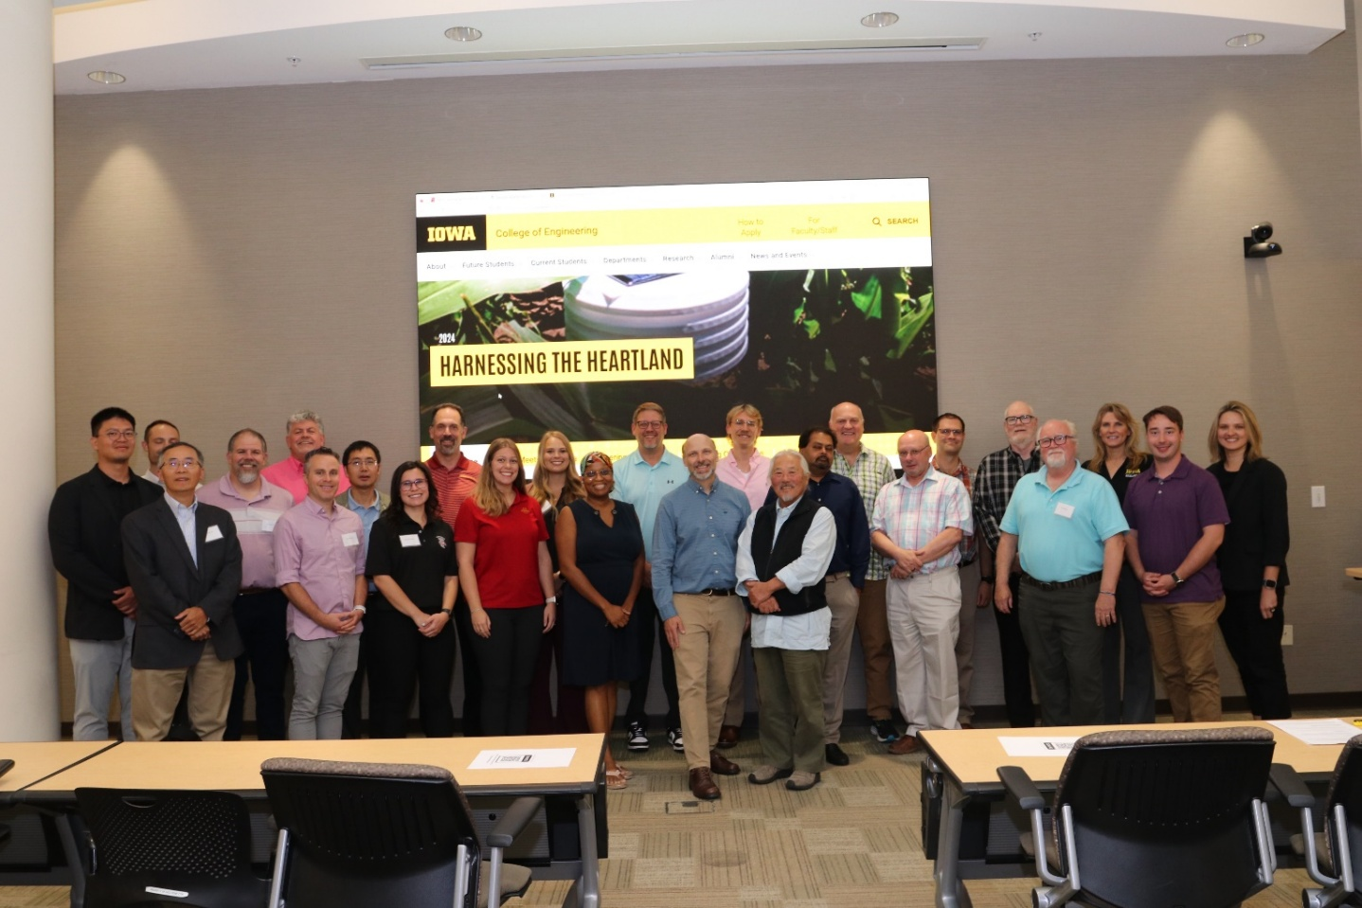
Attendees at the Iowa HEART workshop held at the University of Iowa during September 10 – 12, 2024.

References:
- Agriculture Productivity in the US, US Department of Agriculture (https://catalog.data.gov/dataset/agricultural-productivity-in-the-u-s)

Rippey, B., The U.S. drought of 2012Weather and Climate Extremes
Volume 10, Part A, December 2015, 57-64.

- Hosseini M., H. Kerner, R. Sahajpal, E. Puricelli, Y. Lu, A. Lawal, M. Humber, M. Mitkish, S. Meyer and I. Becker-Reshef, Evaluating the Impact of the 2020 Iowa Derecho on Corn and Soybean Fields Using Synthetic Aperture Radar, Remote Sens. 2020, 12, 3878; doi:10.3390/rs12233878.
- Smith A., and R. Katz, US billion-dollar weather and climate disasters: data sources, trends, accuracy and biases, Nat Hazards (2013) 67:387–410.

- Fifth Climate Assessment, US Global Change Office, 2023 (https://nca2023.globalchange.gov/#overview)

